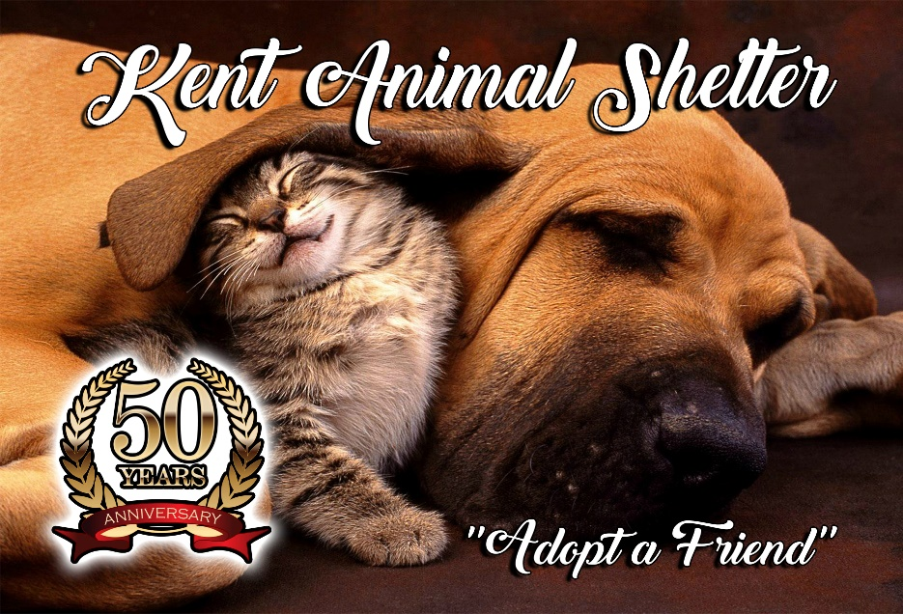

Surgical Release-Kent Spay/Neuter Clinic

Surgical Release – All of our veterinarians are licensed in the State of New York. This facility is not a hospital or a full care facility for the treatment of sick or injured animals. It is a specialized clinic established primarily for the purpose of spaying and neutering dogs and cats. All surgery and services are performed at the risk of the owner. The surgery performed is a major surgery. Pregnant females, those in heat may be spayed but the risk to the animal may be increased significantly. There may be additional charges for any additional time spent in surgery due to complications. These additional charges must be paid upon pick up. The veterinarian may disqualify any animal if in his/her judgement the animal does not appear to be in optimum health. Consent From and Waiver: I request the Kent Animal Shelter to spay/neuter my cat or dog, and I agree to waive any or all claims against the spay clinic and the Kent Animal Shelter, the officers and employees, in the event of escape or injury or death of my animal. Every possible precaution and the best possible medical care will be exercised while the animal is a patient at the clinic. I hereby declare under penalty of perjury that I am the owner of (or authorized by the owner to present for this surgery) the above described animal.
Date_______________

Owner's or authorized representative's Signature________________________________

Email address_____________________________
Phone #______________________________________
*Please sign and date this document before you arrive at the clinic for your appt.

